Homework # 7

Ruchi Panwar (rpanwar@kent.edu)

Advance Database

Fall 2015

Professor: Dr. Gregory S DeLozier

Nov 3, 2015

**TinyDB Todo App (NoSQL)**

1. Items.py & app.py

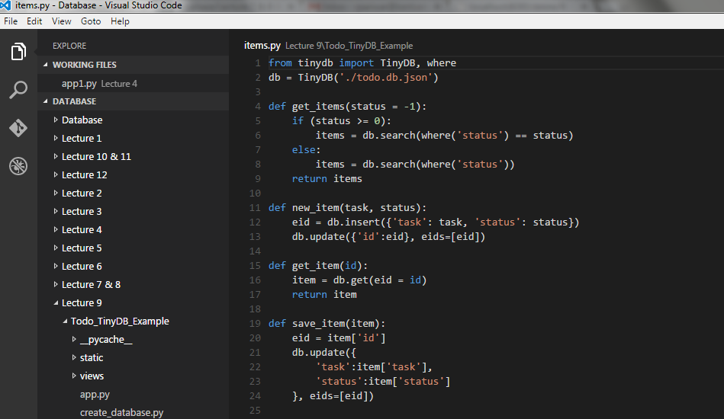

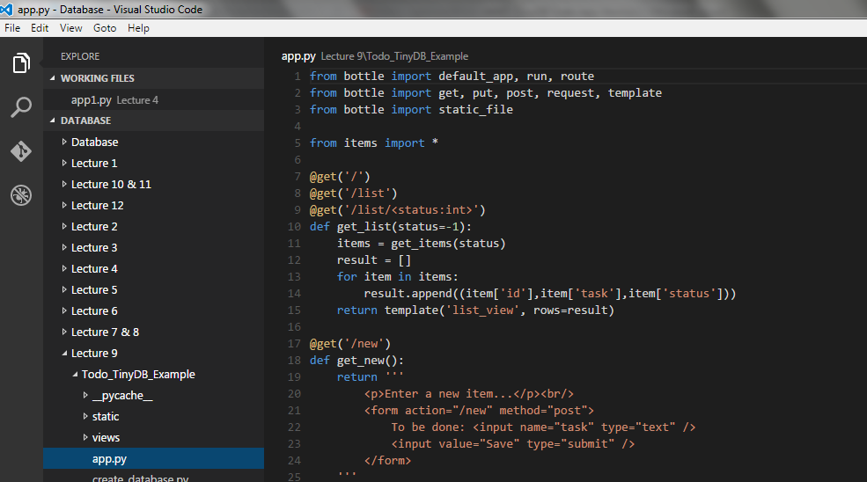

1. Code can be found on the below Github links (Lecture 9)

<https://github.com/rpanwar01/Database/tree/master/Lecture%209/Todo_TinyDB_Example>

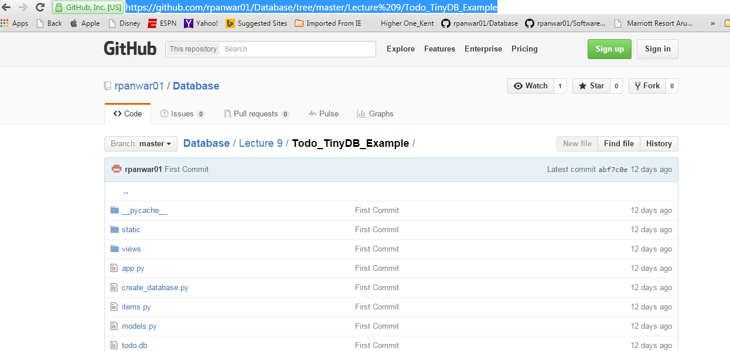

1. Execution and output of Todo app:

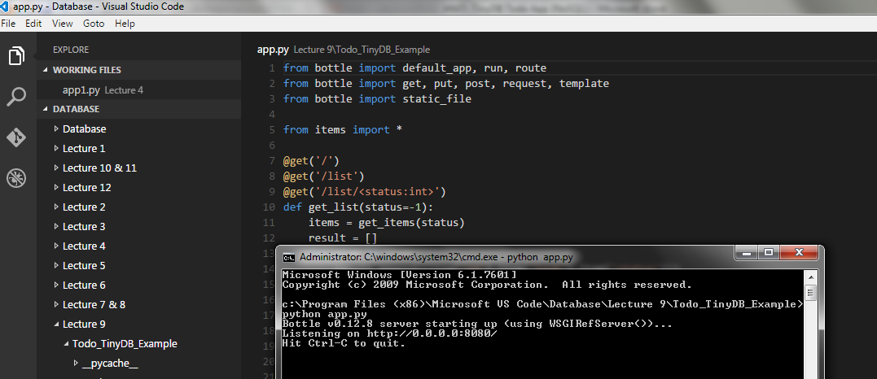

1. Home page of Todo app:

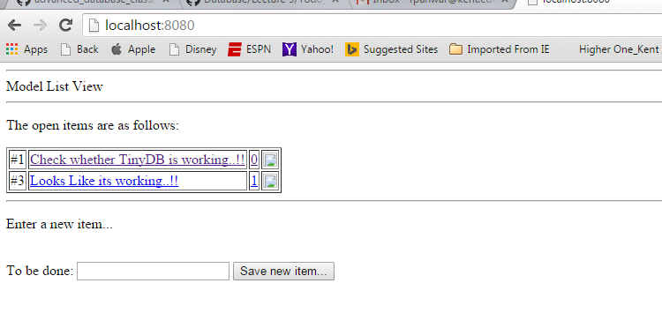

1. Edit an Item:

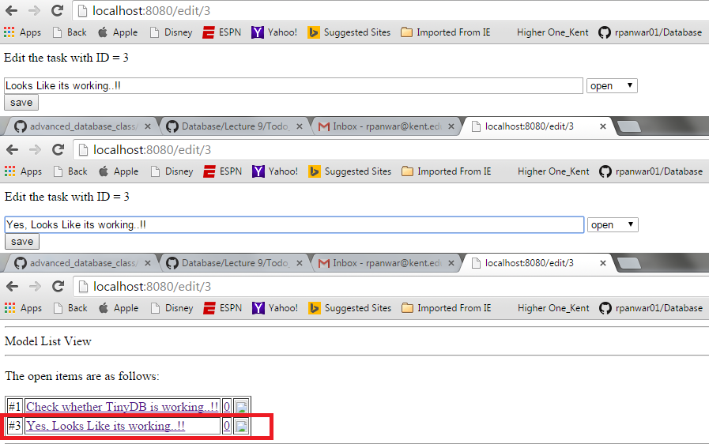

1. Add new Item:

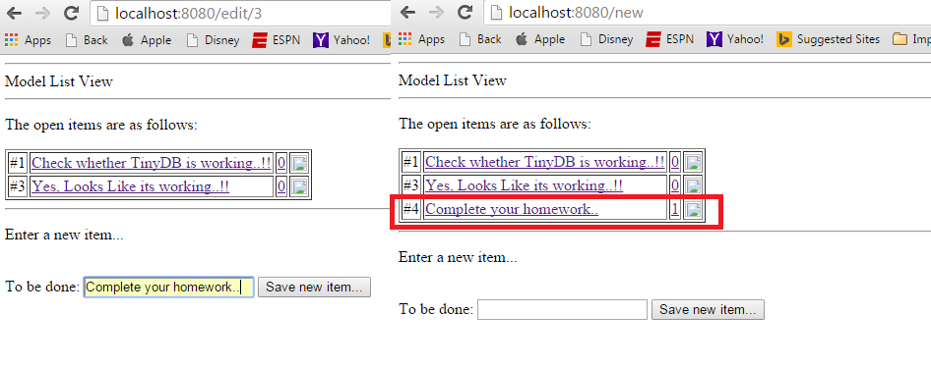

1. Delete an Item:

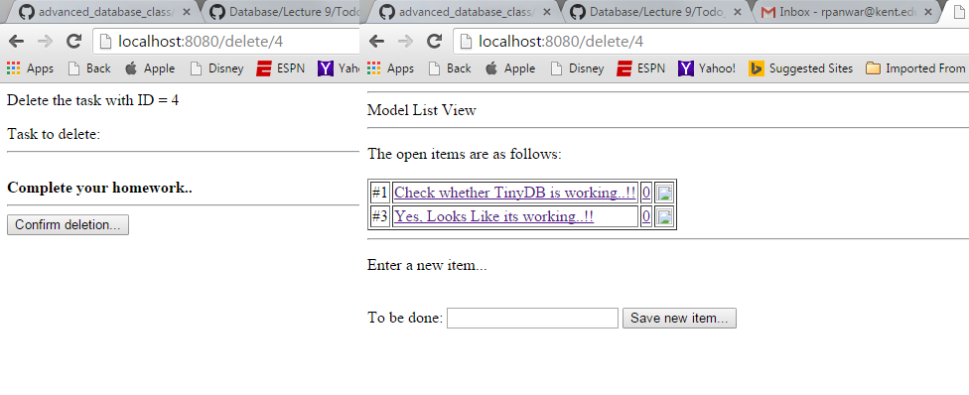

**Working With TinyDB At Home**

